Team ID: PNT2022TMID12665

Project Name: IOT based safety gadgets for child safety monitoring and notification.

1. **Image showing the Backlogs created in the Jira Software(PETA Spring1,PETA Spring2, PETA Spring3, PETA Spring4)**

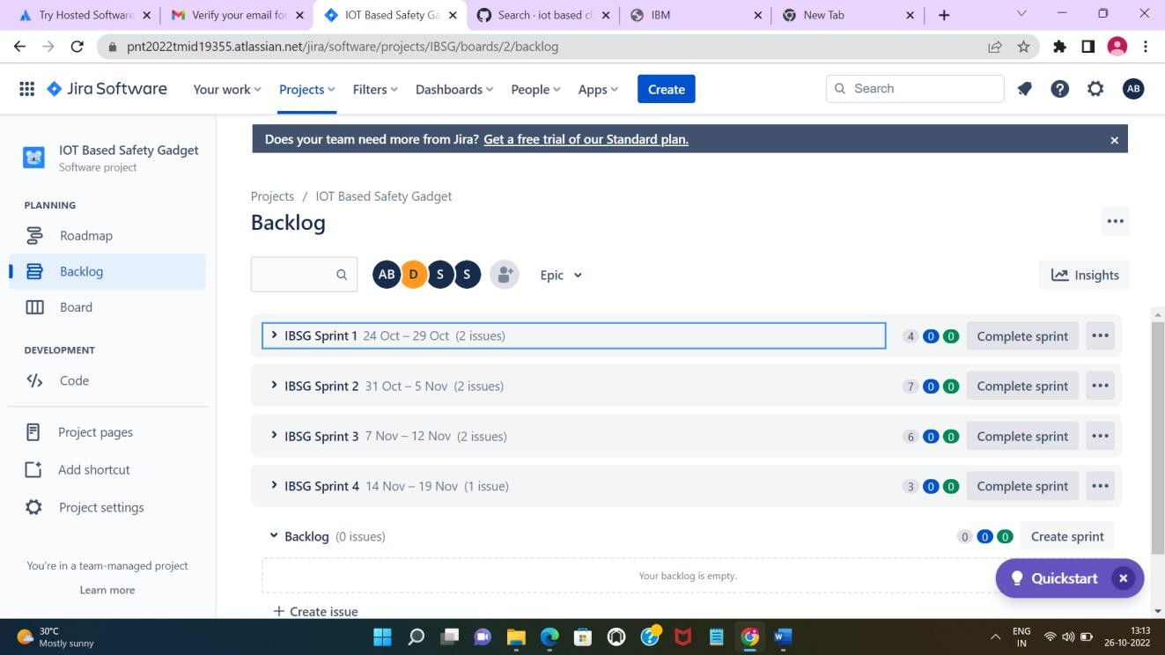

1. **Image showing the User Stories in the respective sprints**

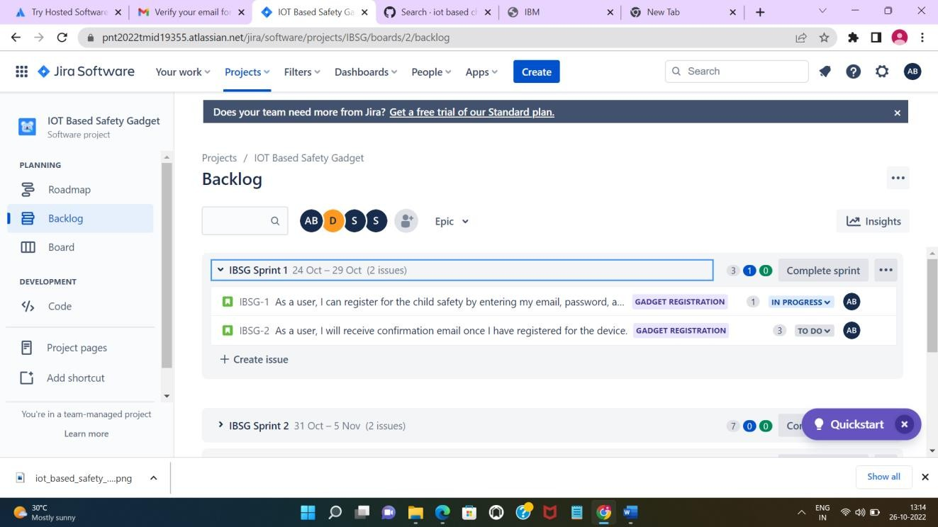

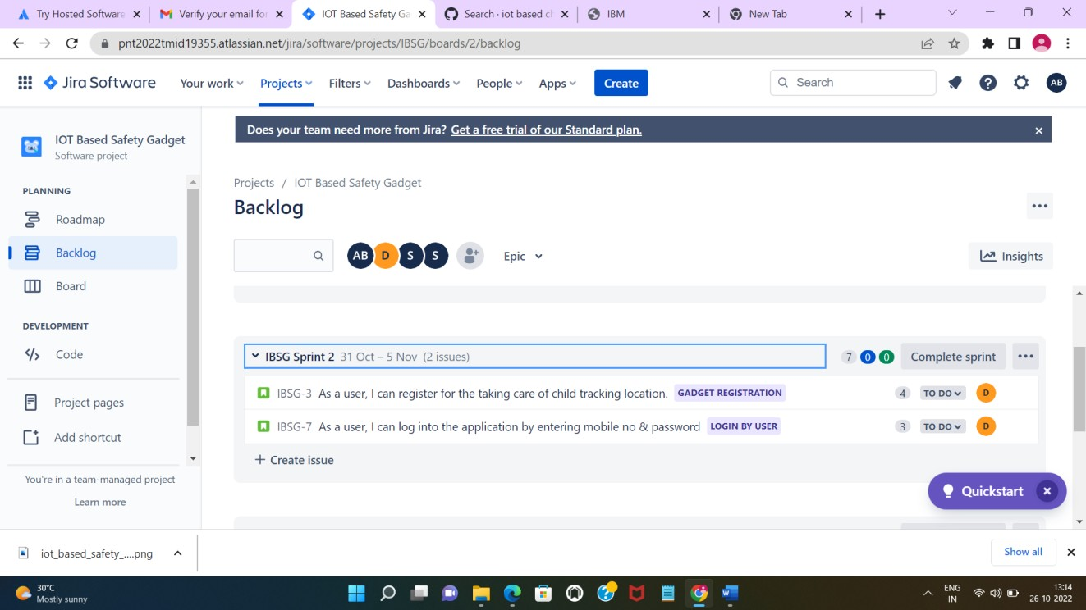

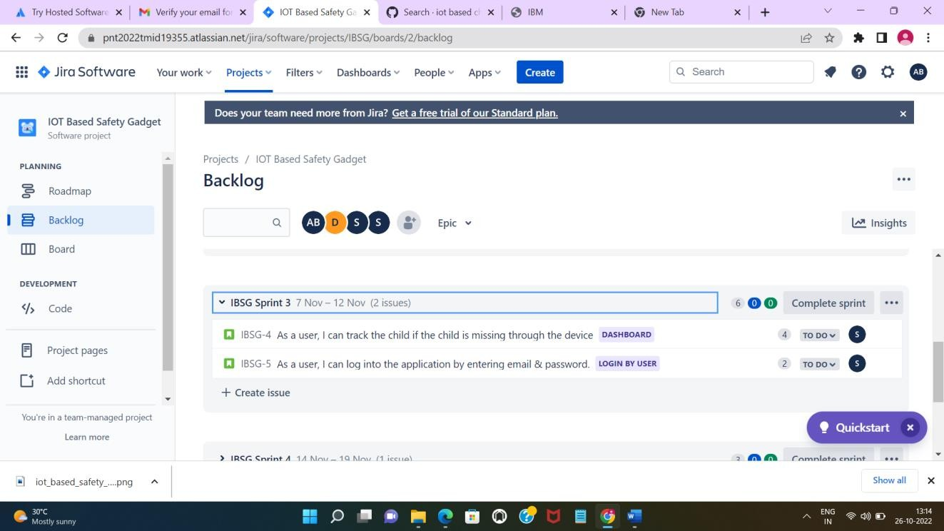

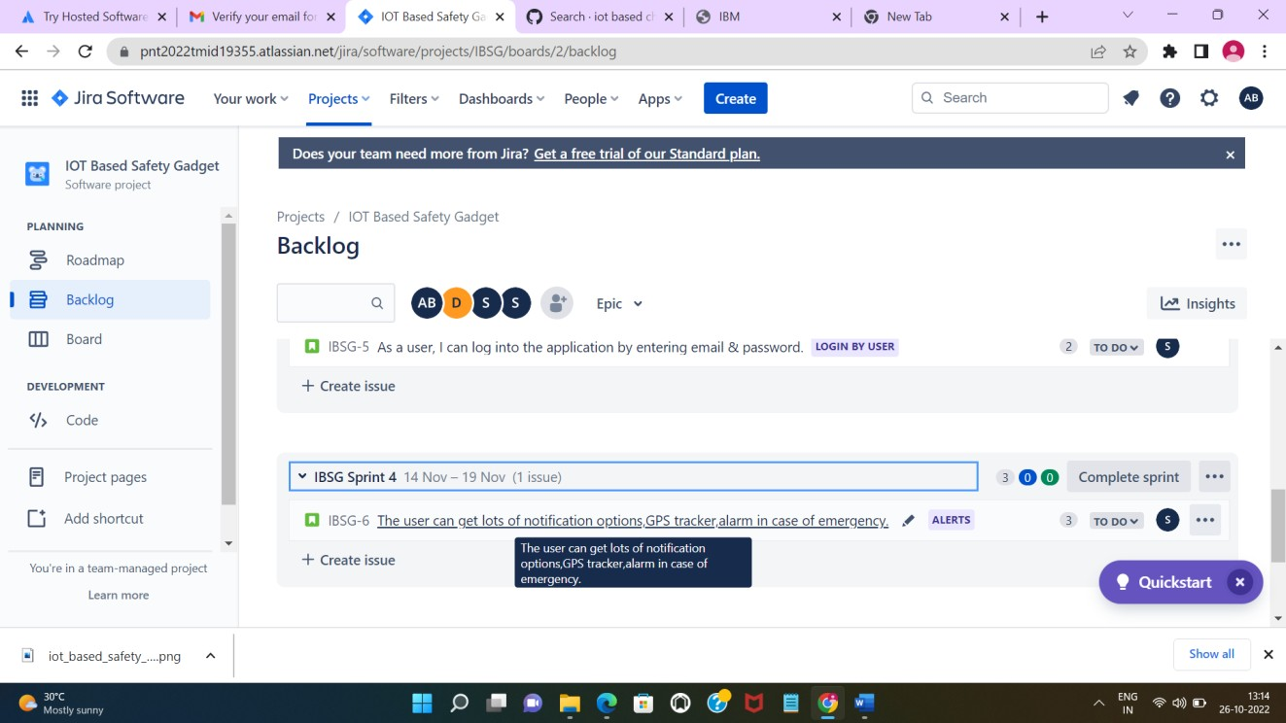

1. **Image showing the working progress of the Sprint**

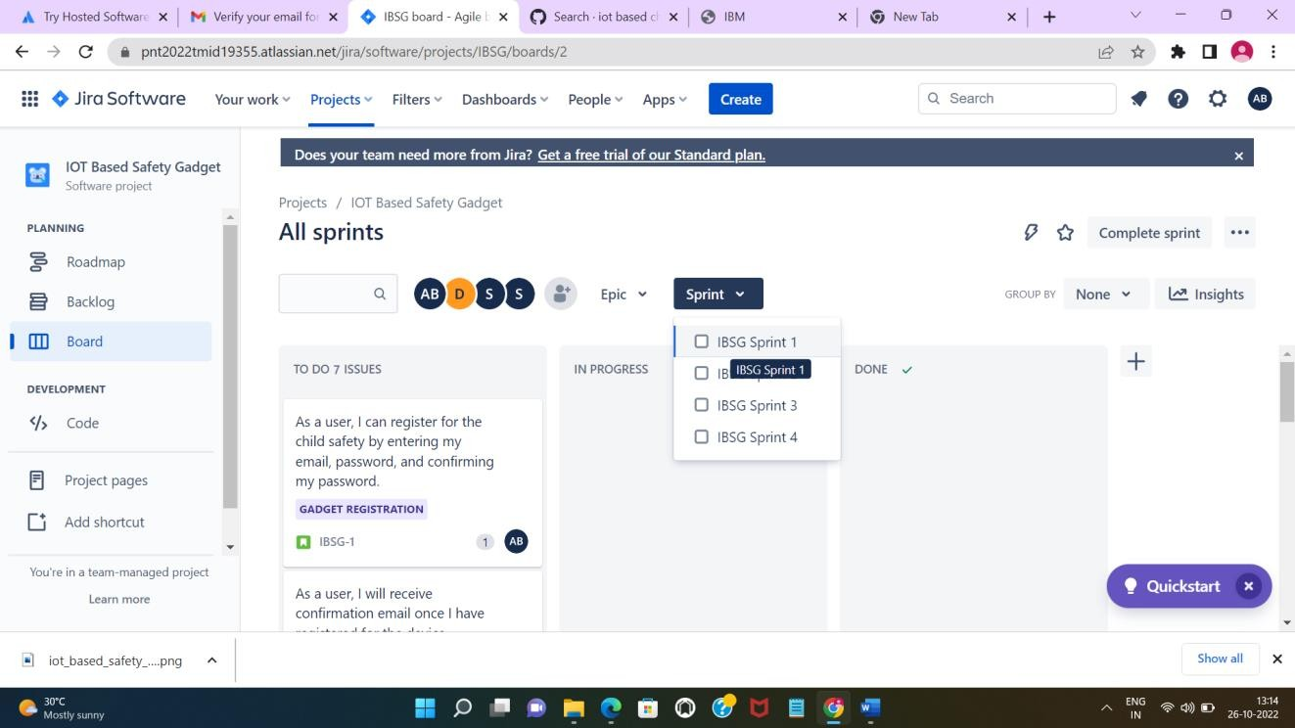

1. **Image showing the Roadmap of the Sprints**

